GRANARD MUNICIPAL DISTRICT

Corporate Affairs,
Aras an Chontae,
LONGFOIRT.

21st March 2017.

To: Each Member of Granard Municipal District.

Dear Member,

You are requested to attend Meeting of Granard Municipal District to be held in
Granard Community Library on Tuesday, 28th March 2017 at 3.30 p.m. to transact business, as set out on the Agenda hereunder.

Yours sincerely,
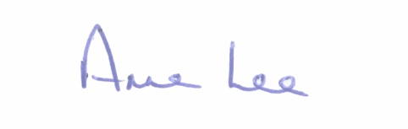

_______________
Anne Lee,
Meetings Administrator.

AGENDA

Prayer before meeting.

1. Confirmation of Minutes of meetings of Granard Municipal District held on the 24th January and 28th February 2017 - copy enclosed.

2. Matters arising from Minutes.

3. Consideration of applications for funding under the 2017 Community Grant Support Scheme - report enclosed.

4. To note Community Facilities Scheme 2017 –summary and documentation attached.

5. Consideration of nominee for 2017 Cathaoirleach’s Awards.

6. Nomination of one member of Granard Municipal District to the County Longford Tourism Committee.

7. Area Engineer’s Progress Report.

8. Notices of Motions submitted by Councillors, as listed hereunder -

Councillor Michael Carrigy.

“I call on Longford Count Council to take out Compulsory Purchase Orders at Ennybegs, Killoe so as to extend the footpaths towards the local National School and the Longford Road side to include improvements of the sightlines on the Ohill Road junction.”

Councillor P.J. Reilly.

“That the Convent Junction in Granard at Mackens Filling Station on the R194 to the N55 to be realigned. The current layout is not suitable for this junction.”

9. Correspondence - copies attached.

- Letter dated 8th February 2017 received from Ballinamuck Community Enterprise Society Ltd. regarding Twinning Event in Essert from the
15th to 20th July 2017.

Letter dated 20th February 2017 received from Ballinamuck Community Enterprise Society Ltd. regarding funding towards Ballinamuck/Essert Twinning 2017.

- Letter dated 24th February 2017 received from the Office of the Minister of Children and Youth Affairs regarding funding for Lus Na Greine Family Resource Centre, Granard.

10. A.O.B.

